

**Accounting for Partnership: Basic Concepts**

Any change in existing agreement of partnership amounts to reconstitution of a firm. As a result, the existing agreement comes to an end and a new agreement comes into existence and the firm continues.

**1. Modes of Reconstitution of a Partnership Firm**  
Reconstitution of a firm can take place in any of the following ways  
(i) Change in the profit sharing ratio of existing partners.  
(ii) Admission of a new partner.  
(iii) Retirement of an existing partner.  
(iv) Death of a partner.

**2. Change in Profit Sharing Ratio among the Existing Partners**  
When one or more partners acquire an interest in the business from another partner(s), it is said to be a change in the profit sharing ratio in a partnership firm. A change in the profit sharing ratio among the existing partners means it is a reconstitution of the firm without admission, retirement or death of a new partner(s).  
The sacrifice made or gain received by a partner is calculated by deducting the new share from the old share of a partner.  
Sacrificing/(Gaining) Share = Old Share – New Share  
Reconstitution of a Partnership Firm: Change in Profit Sharing Ratio

**3. Adjustments required at the Time of Change in Profit Sharing Ratio (i) Determination of Sacrificing Ratio and Gaining Ratio**  
**New Profit Sharing Ratio** It is the ratio in which the partners are to share profits/losses in future.  
**Sacrificing Ratio** It is the ratio in which the partners have agreed to sacrifice their share of profit in favour of other partner or partners. This ratio is calculated by taking out the difference between old profit share and new profit share.  
Sacrificing Ratio = Old Ratio – New Ratio  
**Gaining Ratio** It is the ratio in which the partners have agreed to gain their share of profit from other partner(s). This ratio is calculated by taking out the difference between new profit share and old profit share.  
Gaining Ratio = New Ratio – Old Ratio  
**(ii) Accounting Treatment of Goodwill**  
The entry to be passed for adjustment of goodwill, when there is a change in profit sharing ratio is  
Gaining Partners’ Capital/Current A/c Dr [In gaining ratio]  
To Sacrificing Partners’ Capital/Current A/c [In sacrificing ratio]  
(Being the adjustment made for goodwill on change in profit sharing ratio)  
Treatment of Existing Goodwill  
Goodwill (if any) appearing in the books of the firm is written-off by debiting it to all partners’ capital accounts in their old profit sharing ratio and by crediting the goodwill account.  
The entry is  
All Partners’ Capital/Current A/c              Dr [In old ratio]  
To Goodwill A/c                                      [With book value of goodwill]  
**(iii) Revaluation of Assets and Reassessment of Liabilities**  
**(a) When Revised Values are to be Recorded in the Books of Accounts**  
An account titled ‘Revaluation account or ‘Profit and loss adjustment account is opened for revaluation of assets and reassessment of liabilities.  
**Format of Revaluation Account**  
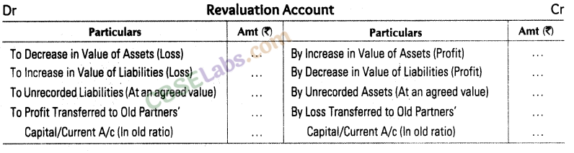  
**(b) When Revised Values are not to be Recorded in the Books of Accounts**  
If partners decide to record the net effect of revaluation of assets and liabilities without affecting the old amount of assets and liabilities, a single adjusting entry ‘ involving the capital accounts of gaining partners and sacrificing partners is passed.  
**(iv) Accounting Treatment of Reserves, Accumulated Profits or Losses**  
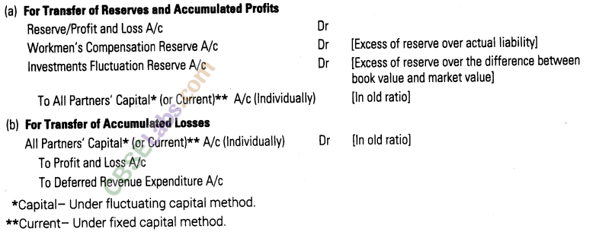  
**Adjustment of Reserves and Accumulated Profits/Losses through Capital Accounts Only**  
A single adjusting entry involving the capital accounts of sacrificing and gaining partner is passed, when the partners decide to record net effect of reserves and accumulated profits/losses without affecting the old figures.  
**In Case of Profit**  
Gaining Partner’s Capital A/c                      Dr  
To Sacrificing Partner’s Capital A/c  
**In Case of Loss**  
Sacrificing Partner’s Capital A/c                 Dr  
To Gaining Partner’s Capital A/c